Day 20 - 12th Aug 2026

Assessment 2 GIT , Linux – on 12th Aug 2026 - 3.30 to 4pm – Done

Recap/ revise of linux and git ..

Till 9.25

Task 1:
What do you understand about integration testing?
9.36 to 9.39

Task 2:
Where do you use it and when ?
9.40 to 9.45

Task 3:
Can you write an integration test for your existing code ?
9.46 to 9.50

For example 🎉
java
@SpringBootTest
@AutoConfigureMockMvc
class UserControllerIT {

@Autowired
private MockMvc mockMvc;

@Test
void testGetUser() throws Exception {
mockMvc.perform(get("/users/1"))
.andExpect(status().isOk())
.andExpect(jsonPath("$.name").value("Alice"));
}
}

Task 4:
What are test containers?
10.05 to 10.09

Task 5:
When do we use ? and what is the need for test containers?
10.10 to 10.15

Task 6:
Can you write a piece of code for your existing application to see how test container works?
10.16 to 10.20

Code sample:

java
@Testcontainers
class UserRepositoryIT {

@Container
static PostgreSQLContainer<?> postgres = new PostgreSQLContainer<>("postgres:15");

@Autowired
private UserRepository userRepository;

@Test
void testSaveUser() {
User user = new User("Alice");
userRepository.save(user);
assertEquals("Alice", userRepository.findById(user.getId()).get().getName());
}
}

Task 7:
What is code coverage ?
10.37 to 10.40

Task 8:
What’s the need for code coverage?
10.41 to 10.45

Raect 👍

📂 Project Structure
Code
banking-app/
│── public/
│ └── index.html
│── src/
│ ├── components/
│ │ ├── AccountDetails.js
│ │ ├── Transactions.js
│ │ └── TransferFunds.js
│ ├── pages/
│ │ ├── Home.js
│ │ ├── Accounts.js
│ │ └── About.js
│ ├── App.js
│ ├── index.js
│ └── api.js
└── package.json

Task 9:

Plz ensure your project is similar to the above structure .. need not have to be exactly same.

Now 1. We will reach out to the Web (Http / Ajax)

lets simulate a backend API call using fetch. In accountDetails.java class in useEffect..

we will use fetch
// we are Simulate backend API call (replace with real endpoint)
fetch("https://api.examplebank.com/accounts/12345")

Step 2:

Access the server from your application

Step 3:

Use routing to implement SPA.

Sample code for your reference 👍

accountDetails.js

import React, { useState, useEffect } from "react";

function AccountDetails() {
// State variables to hold account info, loading status, and error messages
const [account, setAccount] = useState(null);
const [loading, setLoading] = useState(true);
const [error, setError] = useState(null);

useEffect(() => {
// 🔄 Simulate backend API call (replace with real endpoint)
fetch("https://api.examplebank.com/accounts/12345")
.then((response) => {
if (!response.ok) throw new Error("Network error"); // Handle HTTP errors
return response.json(); // Parse JSON response
})
.then((data) => {
setAccount(data); // Save account data in state
setLoading(false); // Stop loading spinner
})
.catch((err) => {
setError(err.message); // Capture error message
setLoading(false);
});
}, []); // Empty dependency array → runs once when component mounts

// Conditional rendering based on state
if (loading) return <p>Loading account details...</p>;
if (error) return <p>Error: {error}</p>;

return (
<div>
<h2>Account Details</h2>
{/* Display account info dynamically */}
<p><strong>Account Number:</strong> {account.accountNumber}</p>
<p><strong>Holder Name:</strong> {account.holderName}</p>
<p><strong>Balance:</strong> ₹{account.balance}</p>
</div>
);
}

export default AccountDetails;

transactions.js

import React, { useState, useEffect } from "react";

function Transactions() {
// State to hold list of transactions
const [transactions, setTransactions] = useState([]);

useEffect(() => {
// 🔄 Fetch transaction history from backend
fetch("https://api.examplebank.com/accounts/12345/transactions")
.then((res) => res.json())
.then((data) => setTransactions(data)) // Save transactions in state
.catch((err) => console.error(err)); // Log errors
}, []);

return (
<div>
<h2>Transaction History</h2>
<ul>
{/* Loop through transactions and render each */}
{transactions.map((txn) => (
<li key={txn.id}>
{txn.date} - {txn.type} - ₹{txn.amount}
</li>
))}
</ul>
</div>
);
}

export default Transactions;

Pages in my app are:

About.js

import React from "react";

function About() {
return (
<div>
<h1>About MyBank</h1>
<p>We provide modern banking solutions with React-powered apps.</p>
</div>
);
}

export default About;

Accounts.js

import React from "react";
import AccountDetails from "../components/AccountDetails";
import Transactions from "../components/Transactions";

function Accounts() {
return (
<div>
<h1>Your Accounts</h1>
<AccountDetails />
<Transactions />
</div>
);
}

export default Accounts;

Home.js

import React from "react";

function Home() {
return (
<div>
<h1>Welcome to MyBank</h1>
<p>Secure banking at your fingertips.</p>
</div>
);
}

export default Home;

Expected output will be similar to ..

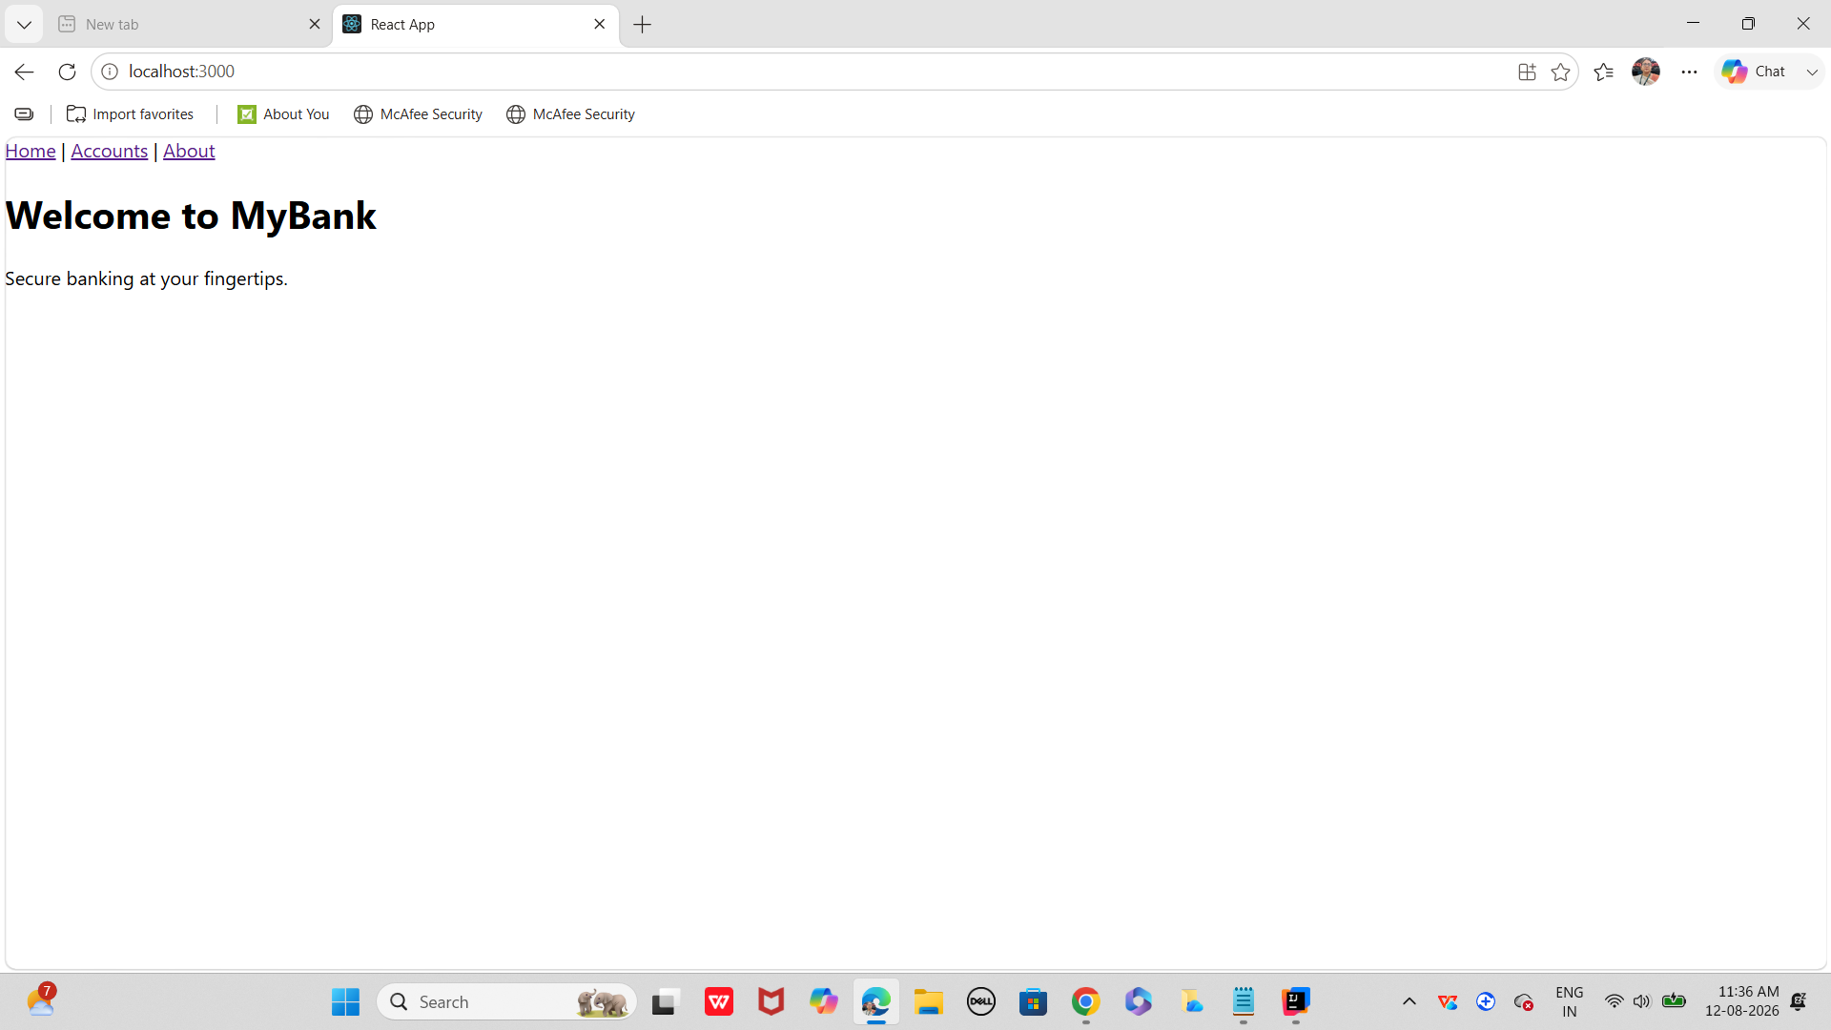

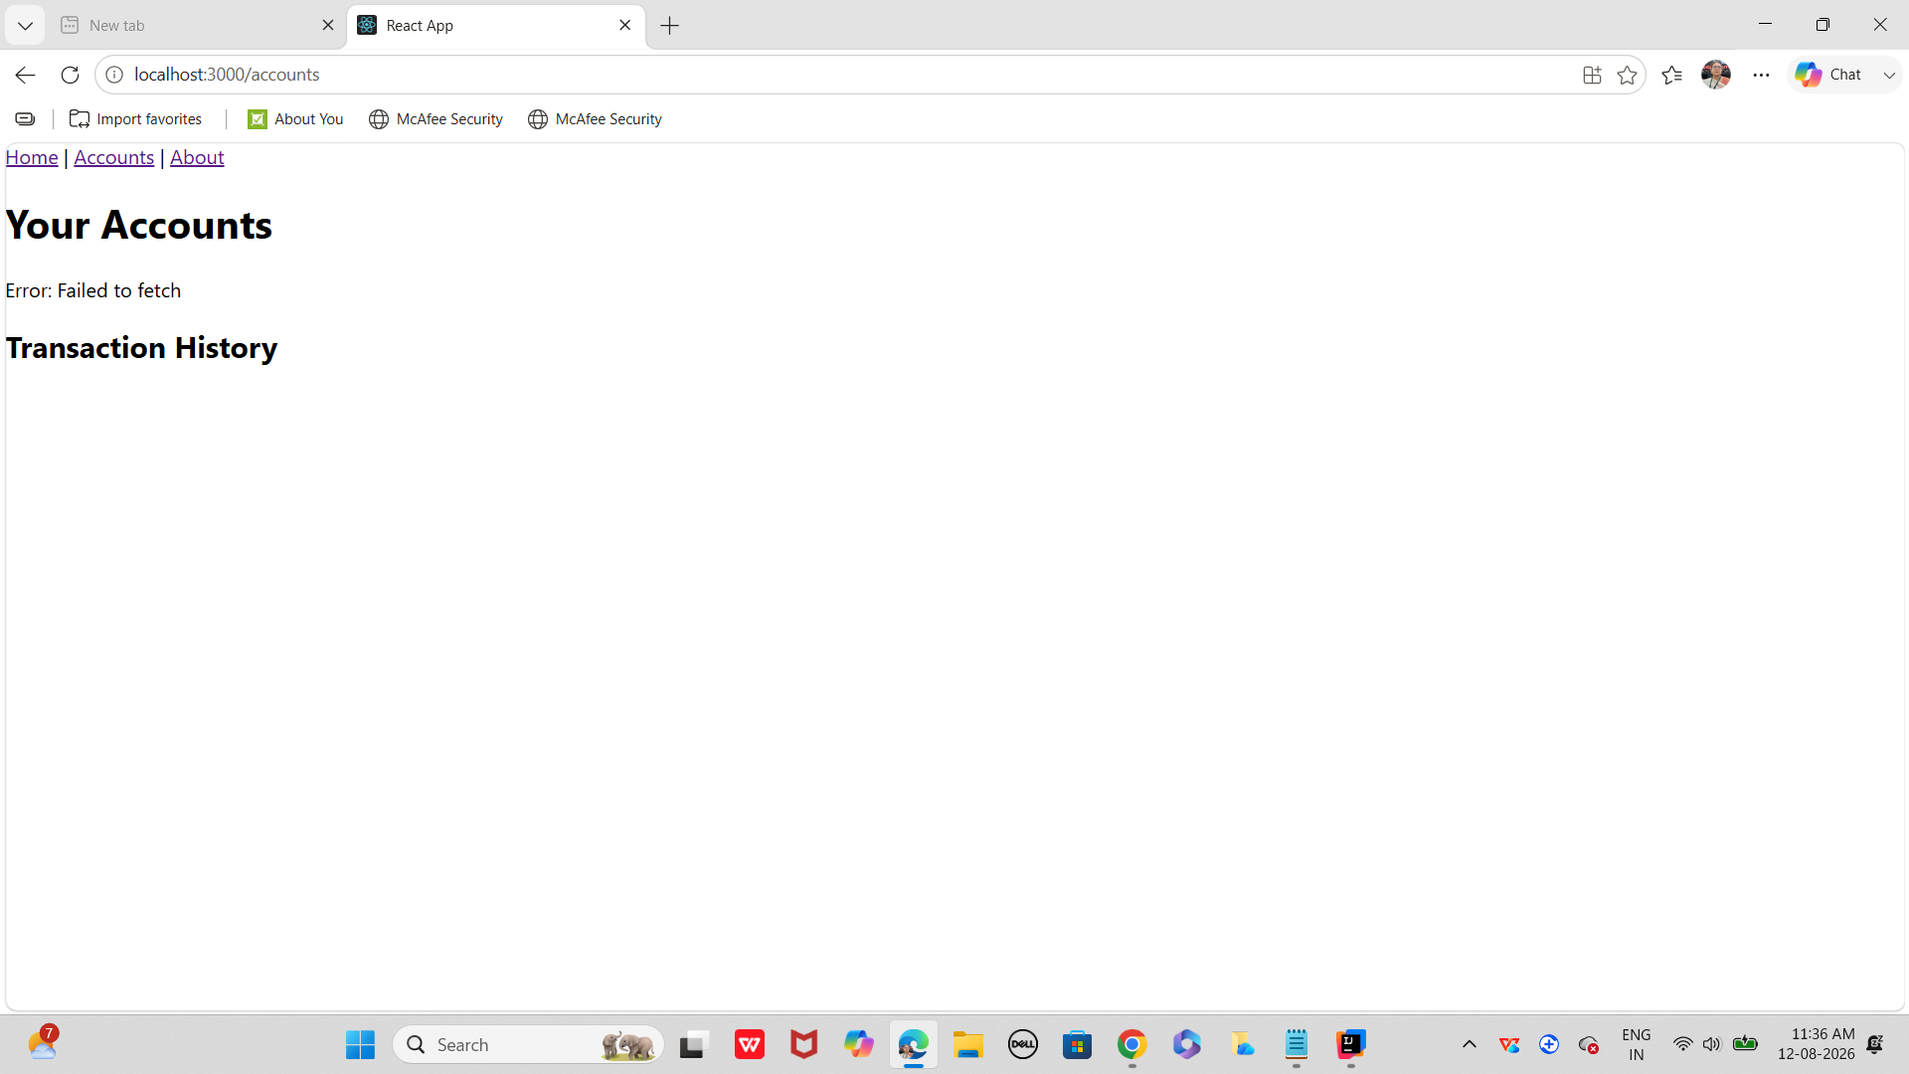

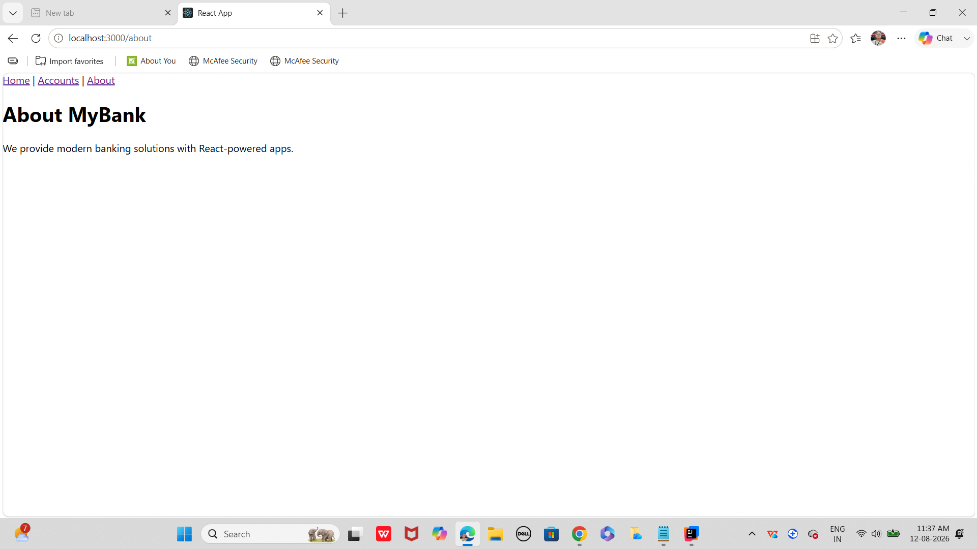

Task 10:

Redux:

What is REdux used for?

Task 11:
Why do we need to maintain the state throughout the app..?

Task 12:
What is useSelector used for ?

Task 13:
After the break we would be working with the Redux ..

In this can you create a store

Step 1:
Import createstore from Redux

show how the state changes based on the action type.. Like if with draw , deposit… etc..

Now create store with a reducer..

Step 2:
Now in app.js use – useSelector and useDispatcher from react-redux;

Access balance from redux store and dispatch action to the dispatch function

Step 3:

Create a controller class like BalanceController.js .. which has component for withdraw and deposit.

index.js, index. html (save in public folder) and package.json code is given for your ref

banking-app/
├── public/
│ └── index.html # Root HTML file
├── src/
│ ├── store.js # Redux store + reducer
│ ├── App.js # Main React component
│ ├── index.js # Entry point, wraps App with Provider
│ └── components/
│ └── BalanceControls.js # Reusable component for deposit/withdraw
├── package.json # Dependencies & scripts
└── README.md # Project instructions

BalanceControls.js

import React from "react";

// Component for deposit and withdraw actions
export default function BalanceControls({ dispatch }) {
return (
<div>
{/* Deposit button */}
<button onClick={() => dispatch({ type: "DEPOSIT", amount: 500 })}>
Deposit ₹500
</button>

{/* Withdraw button */}
<button onClick={() => dispatch({ type: "WITHDRAW", amount: 200 })}>
Withdraw ₹200
</button>
</div>
);
}

store.js

// Redux store setup
import { createStore } from "redux";

// Reducer: defines how state changes based on actions
function bankReducer(state = { balance: 0 }, action) {
switch (action.type) {
case "DEPOSIT":
// Add the deposit amount to balance
return { balance: state.balance + action.amount };
case "WITHDRAW":
// Subtract the withdrawal amount from balance
return { balance: state.balance - action.amount };
default:
// Return current state if action type is unknown
return state;
}
}

// Create store with reducer
const store = createStore(bankReducer);

export default store;

public/ Index.html

<!DOCTYPE html>
<html lang="en">
<head>
<meta charset="UTF-8" />
<title>Banking App</title>
</head>
<body>
<div id="root"></div>
<!-- React will mount here -->
</body>
</html>

index.js

import React from "react";
import ReactDOM from "react-dom/client";
import { Provider } from "react-redux";
import App from "./App";
import store from "./store";

// Entry point: wrap App with Redux Provider
ReactDOM.createRoot(document.getElementById("root")).render(
<Provider store={store}>
<App />
</Provider>
);

Package.json

json
{
"name": "banking-app",
"version": "1.0.0",
"private": true,
"dependencies": {
"react": "^18.0.0",
"react-dom": "^18.0.0",
"react-redux": "^8.0.0",
"redux": "^4.2.0"
},
"scripts": {
"start": "react-scripts start"
}
}

Task 14:

What is Node JS for?
4.28 to 4.31

Task 15:
Why use Node Js?
4.32 to 4.34

Task 16:
What are Common and modern modulus in Nodejs ?
4.35 to 4.38

============================================================================

Jacoco code for your reference

Demo with JaCoCo (Maven):
xml
<plugin>
<groupId>org.jacoco</groupId>
<artifactId>jacoco-maven-plugin</artifactId>
<version>0.8.8</version>
<executions>
<execution>
<goals>
<goal>prepare-agent</goal>
</goals>
</execution>
<execution>
<id>report</id>
<phase>verify</phase>
<goals>
<goal>report</goal>
</goals>
</execution>
</executions>
</plugin>
Generates an HTML report showing coverage percentages.

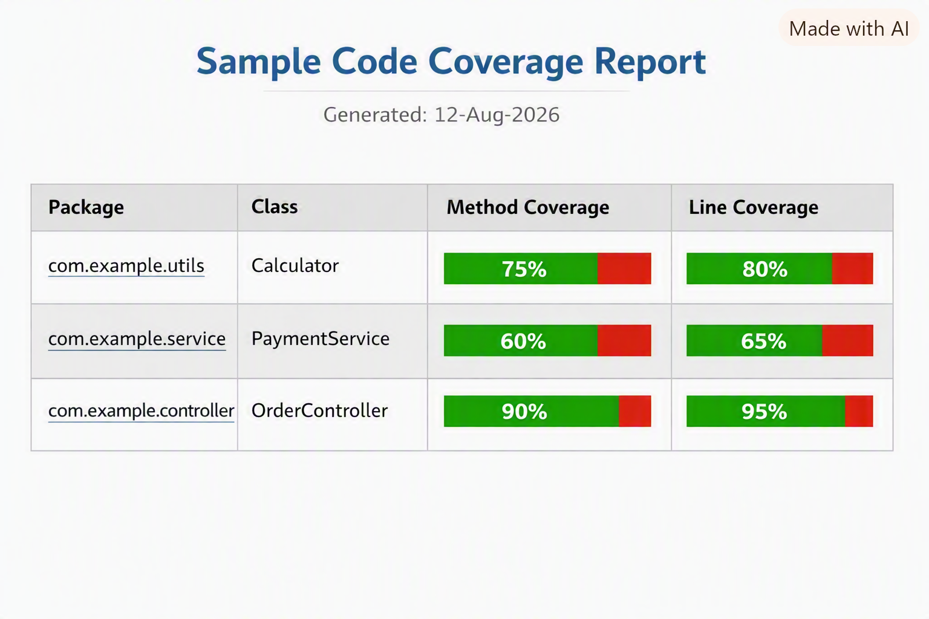

Home Task:

- What is the difference between Node.js and a traditional web server like Apache or Nginx?
- Explain the event-driven architecture of Node.js.
- How does the single-threaded model in Node.js handle concurrency?
- What is the role of the V8 engine in Node.js?
- Why is Node.js considered non-blocking?
- What is the difference between callbacks, promises, and async/await in Node.js?
- How does the event loop work, and what are its phases?
- What is the difference between process.nextTick() and setImmediate()?
- How does Node.js handle I/O operations asynchronously?
- How does the require() function work internally?
- What is the purpose of package.json and package-lock.json?
- Explain the difference between dependencies and devDependencies in npm.

